What is an SMTP server

The acronym [**SMTP**](http://www.serversmtp.com/en/what-is-smtp) stands for **Simple Mail Transfer Protocol**, the procedure behind the email flow on the internet.

What happens when you send out an email? The process of email delivery is actually quite similar to classical mail: an organized system takes care of your envelope and through a series of steps it drops it off to your recipient. In this process, the **SMTP server** is simply a **computer running SMTP**, and which acts more or less like the postman. Once the messages have been picked up they are sent to this server, which takes care of concretely delivering emails to their recipients.

Basically, the journey of a message from your computer to the recipient's is like this:

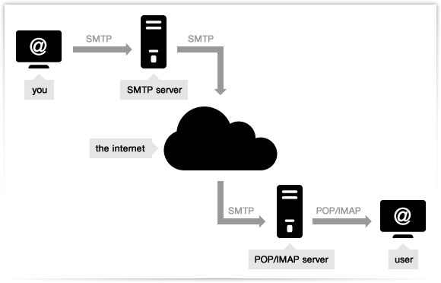

* You send an email with your webmail or **mail client** from your address (e.g. mark@website.com) to a given recipient (e.g. jane@domain.com). In jargon, the webmail or client is called **Message User Agent**, or **MUA**.
* The message is sent normally via [**port 25**](http://www.serversmtp.com/en/port-for-smtp) to an SMTP server (named for instance mail.website.com) which is given to your client when you set it up and acts as a Message Transfer Agent or MTA. Client and server start a brief "conversation" where the latter checks all the data concerning the message's transmission (sender, recipient, domains, etc.). Note that SMTP language defines only the message's transmission, and doesn't deal with its body content.
* Then, if the domain where your recipient has his account is directly connected to the server, the email is immediately delivered. If it's not the case, the SMTP hands it to another **incoming server** closer to the recipient (in jargon these passages are called **relays**). In our example, the Website server connects with the Domain server, which (if everything has gone right) receives the email and stores it.
* What if the recipient's server is down or busy? The SMTP host simply drops the message to a **backup server**: if none of them is available, the email is queued and the delivery is retried periodically. After a determined period, however, the message is returned as undelivered.
* If there are no issues, however, the final segment is controlled by [**POP**](http://www.serversmtp.com/en/pop-and-smtp), another protocol that picks up the email from the receiving server and puts it into the recipient's inbox.

It must be underlined, though, that the SMTP servers used when you send your "normal emails" – e.g. the ones associated to providers like Hotmail, Gmail and Yahoo Mail – are **shared among users** and they are based on non-dedicated IPs. Which means that you could end up to rely on an IP that is also used by a spammer: a fact that will negatively affect the correct delivery of your messages. Also, common providers establish some **strict limits** on the number of emails you can send (e.g. Yahoo's restriction is 100 email per hour).

That is why, if you plan to send a **massmail** or set up an **email campaign** we recommend to use a **professional outgoing email service** like [turboSMTP](http://www.serversmtp.com/en/tsmtpregistration1.php" \o "SMTP service), which guarantees a controlled IP and avoids all the aforementioned problems.

You can register and [get a lifetime package of 6000 free emails per month](http://www.serversmtp.com/en/tsmtpregistration1.php), then upgrade to the plan that best suits your options.﻿

SMTP settings

When you configure a mail client, you need to detail your **SMTP settings** which will ensure a proper connection with your **SMTP server provider** – and thus a correct delivery of your emails.

There are lots of free SMTP servers associated to common ISPs and email providers (the most popular being Gmail and Yahoo), but only a [**professional outgoing server**](http://www.serversmtp.com/en/tsmtpregistration1.php) can guarantee the highest **deliverability** of all your emails. In fact, not every sent message is automatically a delivered one, as even a legitimate email may be rejected by a severe antispam filter. A dedicated SMTP server like [turboSMTP](http://www.serversmtp.com/en/tsmtpregistration1.php" \o "smtp server), on the contrary, provides a reliable way to avoid these annoying troubles.

That said: how to **set up an SMTP server** for a mail client? The typical window would look like this:﻿

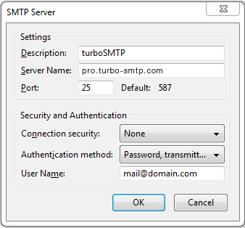

Here's a quick explanation of all the fields:

* **Description**: it's an informal name associated to your SMTP server.
* **Server name**: the actual SMTP specification. Below you find a handy list of all the server names for the most common email providers.
* **Port**: SMTP servers normally use port 25 to work, but [there are other options](http://www.serversmtp.com/en/smtp-port-number).
* **Connection security**: the standard SMTP email transfer goes without encryption, so it can be a good idea to secure it with STARTTLS or SSL/TLS.
* **Authentication method**: it can be a plain text password, a cyphered one, POP before SMTP, CRAM-MD5, KERBEROS, NTLM, etc.
* **User Name**: your email address.

And here's a list of the **most popular server names**. If you don't find yours, check out our article about ["What is my SMTP"](http://www.serversmtp.com/en/what-is-my-smtp) or contact your email provider.﻿

|  |  |  |
| --- | --- | --- |
| **PROVIDER** | **URL** | **SMTP** |
| **1&1** | 1and1.com | Smtp.1and1.com |
| **Airmail** | Airmail.net | Mail.airmail.net |
| **AOL** | Aol.com | Smtp.aol.com |
| **AT&T** | Att.net | Outbound.att.net |
| **Bluewin** | Bluewin.ch | Smtpauths.bluewin.ch |
| **BT Connect** | Btconnect.com | Mail.btconnect.tom |
| **Comcast** | Comcast.net | Smtp.comcast.net |
| **Earthlink** | Earthlink.net | Smtpauth.earthlink.net |
| **Gmail** | Gmail.com | Smtp.gmail.com |
| **Gmx** | Gmx.net | Mail.gmx.net |
| **HotPop** | Hotpop.com | Mail.hotpop.com |
| **Libero** | Libero.it | Mail.libero.it |
| **Lycos** | Lycos.com | Smtp.lycos.com |
| **O2** | o2.com | Smtp.o2.com |
| **Orange** | Orange.net | Smtp.orange.net |
| **Outlook.com (former Hotmail)** | Outlook.com | Smtp.live.com |
| **Tin** | Tin.it | Mail.tin.it |
| **Tiscali** | Tiscali.co.uk | Smtp.tiscali.co.uk |
| **Verizon** | Verizon.net | Outgoing.verizon.net |
| **Virgin** | Virgin.net | Smtp.virgin.net |
| **Wanadoo** | Wanadoo.fr | Smtp.wanadoo.fr |
| **Yahoo** | Yahoo.com | Mail.yahoo.com |
|  |  |  |

What is an SMTP port

What **port** should you chose for your [**SMTP server**](http://www.serversmtp.com/en/what-is-smtp-server) ﻿when you're setting it on a mail client?

Simply put, **computer ports** are the communication endpoints of a computer connected to a network. They are separated to differentiate the several processes and make it easier to handle them: so each one has a particular purpose and is associated to a specific protocol.

Usually an outgoing server employs **port 25**: it's the **default SMTP port**. However, some IPs deny its use because of the massive spam and malware traffic by which is affected. This issue is raised in particular when you need to switch to another ISP – for instance, when you're travelling and connecting to a new provider. In this case you can try to use **port 587** or **port 465** to avoid the block.

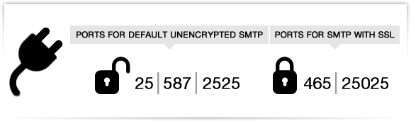

More in detail: port 587 is supported by almost every outgoing SMTP server and it's useful for unencrypted or TLS connections; while port 465 is the right choice if you need to connect via SSL.

[**turboSMTP**](http://www.serversmtp.com/en/tsmtpregistration1.php) can work both on port 587 and 465, but also on 2525 and 25025. Moreover, it completely avoids the "another ISP" issue: in fact, once you have set our SMTP as default you don't need to configure it again or switch to other ports.

# Free SMTP server

What's a **free SMTP server**? Easy question.

First of all, an **SMTP server** is the machine that delivers the emails you send with a mail client. And any free email provider comes with an associated **free SMTP server** which takes care right of its delivery process: Gmail, for instance, uses gmail.smtp.com.

Now the main problem with a common free SMTP provider is that it cannot guarantee a proper [**deliverability**](http://www.serversmtp.com/en/email-deliverability) of bulk emails – like newsletters – because it doesn't use monitored IPs.

That is, you can end up sending your emails from a **blacklisted IP** or from an IP shared with a spammer – with dreadful consequences on your **email delivery rate**. (Also, free SMTPs come with restrictions about the number of messages or recipients that you can handle per day).

That's why [turboSMTP](http://www.serversmtp.com/en/tsmtpregistration1.php" \o "turboSMTP) provides a professional server, also in a completely free version: matter of fact, you can get immediately [**6000 free SMTP relays per month**](http://www.serversmtp.com/en/tsmtpregistration1.php)**lifetime** (and in case upgrade according to your needs).

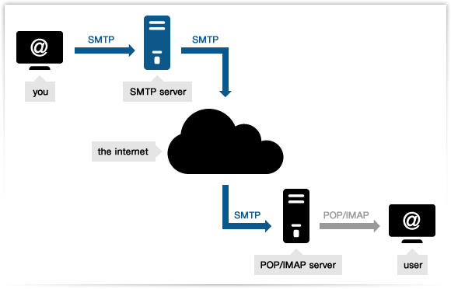

**How to Configure Email Notification in Jenkins?**

Posted by [Pankaj Khurana](http://www.360logica.com/blog/author/pankaj-khurana)

1. Open Jenkins using the following URL: http://localhost:8080/ on any browser.

[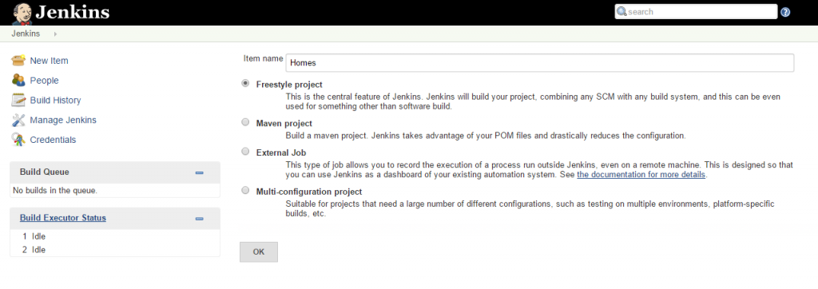](http://www.360logica.com/blog/wp-content/uploads/2016/02/image001.png)

2. Click the ‘Manage Jenkins’ menu option displayed at the right side of the screen. You will be redirected to the ‘Manage Jenkins’ page, where you need to select the ‘Manage Plugin’ option.

[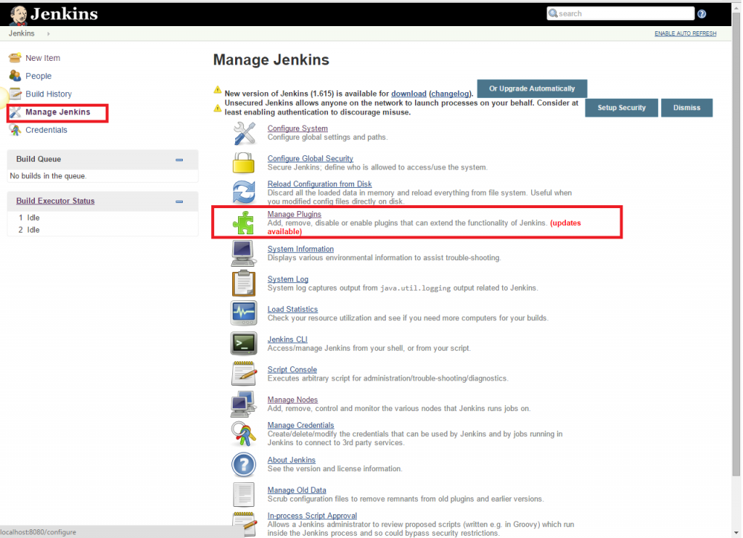](http://www.360logica.com/blog/wp-content/uploads/2016/02/image002.png)

3. Click the ‘Available’ tab present at the top of the ‘Manage Plugin’ page.

[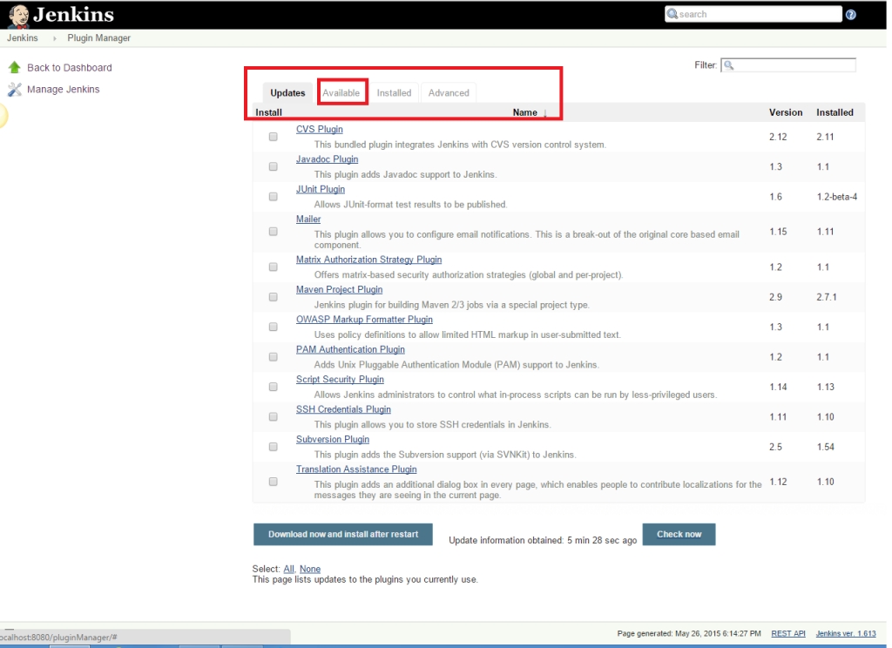](http://www.360logica.com/blog/wp-content/uploads/2016/02/image003.png)

4. Start typing ‘Notification’ in the ‘Filter’ field displayed at the top-right side of the ‘Manage Plugin’ page. Click the checkbox next to the ‘Email-ext plugin’ option. Click the ‘Install without restart’ button.

[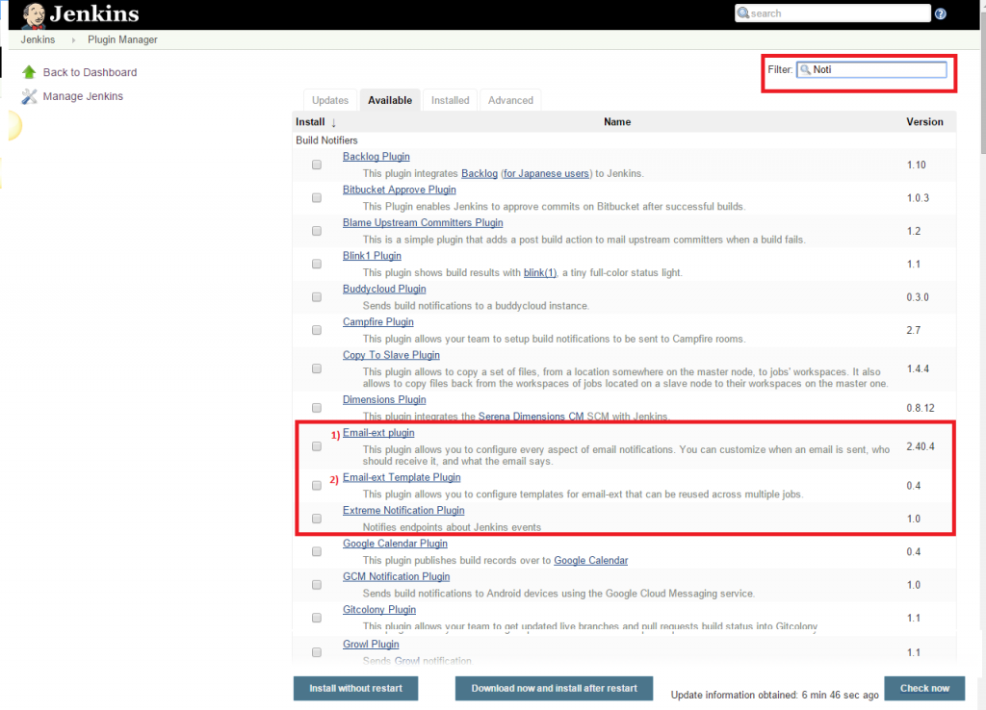](http://www.360logica.com/blog/wp-content/uploads/2016/02/image004.png)

5. Now, click the checkbox next to the ‘Email-ext Template Plugin’ option. Click the ‘Install without restart’ button.

[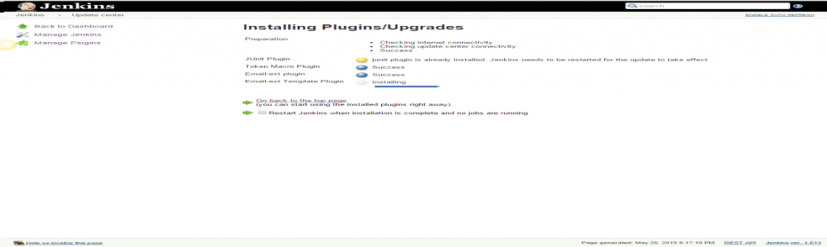](http://www.360logica.com/blog/wp-content/uploads/2016/02/image005.png)

6. Go to the Jenkins home page and click the ‘Manage Jenkins’ menu option. Then, select the ‘Configure System’ option.

[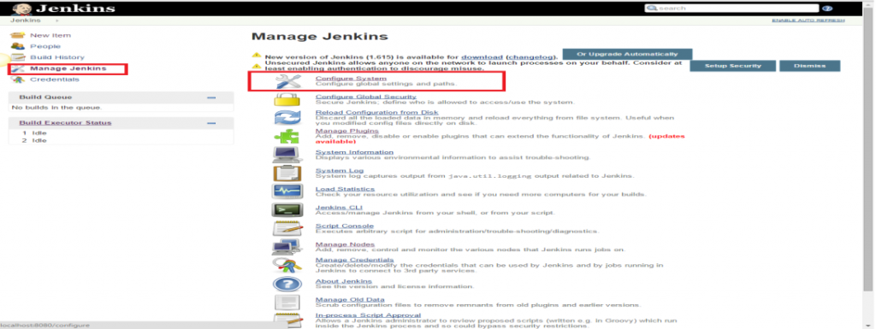](http://www.360logica.com/blog/wp-content/uploads/2016/02/image006.png)

7. Enter the SMTP server name under ‘Email Notification’. Click the ‘Advanced’ button and then click the checkbox next to the ‘Use SMTP Authentication’ option. Now, set the following fields.

* + **SMTP server name** : smtp.gmail.com
  + **User name**: user_email_id@gmail.com
  + **Password**: 123456
  + **Use SSL**: Checked
  + **SMTP Port**: 456

[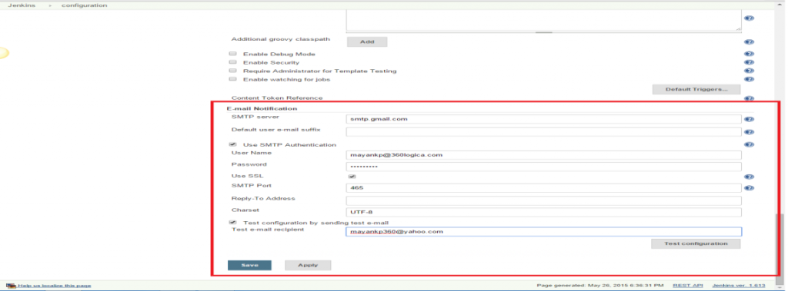](http://www.360logica.com/blog/wp-content/uploads/2016/02/image007.png)

8. Check the email notification functionality by clicking the checkbox next to the ‘Test configuration by sending Test e-mail recipient’ option. Enter a valid email id and click the ‘Test configuration’ button to check whether the email id is valid or not.

[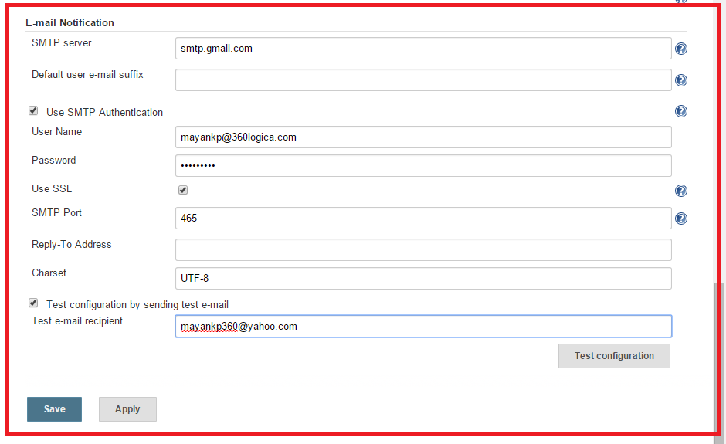](http://www.360logica.com/blog/wp-content/uploads/2016/02/image008.png)

9. Go to the home page and click on a created job, like Homes. Then, click the ‘Configure’ option.

[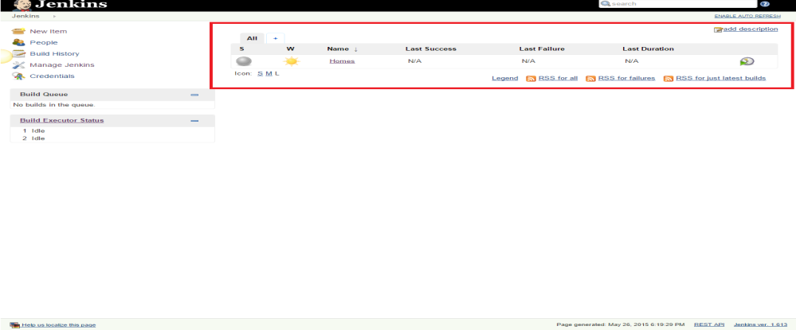](http://www.360logica.com/blog/wp-content/uploads/2016/02/image009.png)

[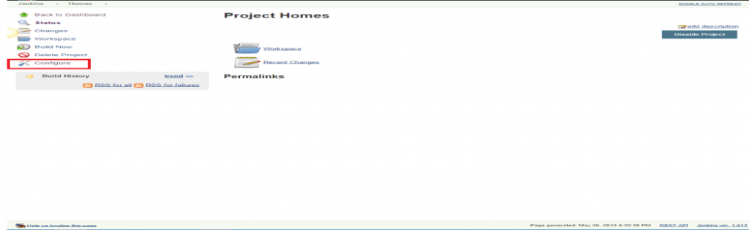](http://www.360logica.com/blog/wp-content/uploads/2016/02/image010.png)

10. Click the ‘Add post-build action’ drop-down.

[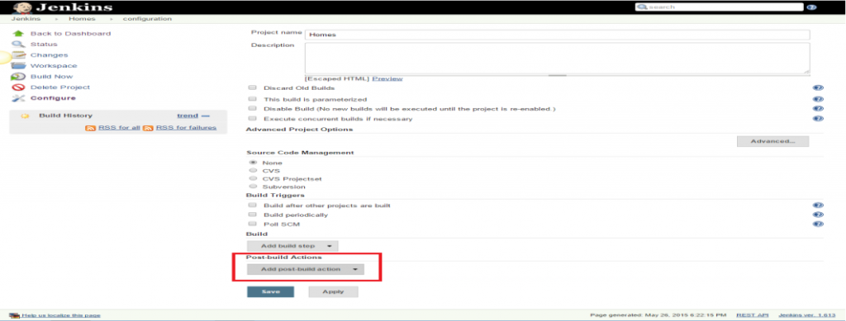](http://www.360logica.com/blog/wp-content/uploads/2016/02/image011.png)

11. Select the ‘E-mail Notification’ value.

[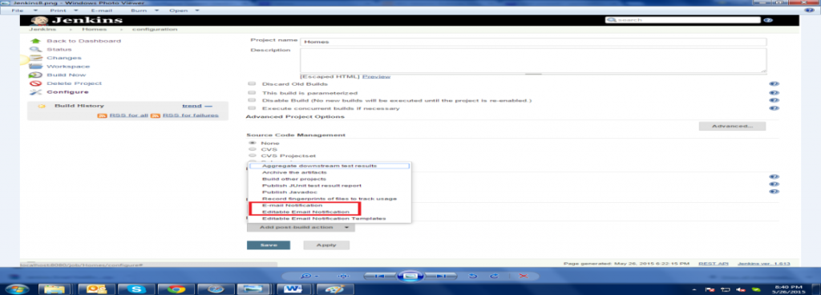](http://www.360logica.com/blog/wp-content/uploads/2016/02/image012.png)

12. Enter the recipient email id in the ‘E-mail Notification’ box and select the checkbox next to the ‘Send e-mail for every unstable build’ option.

[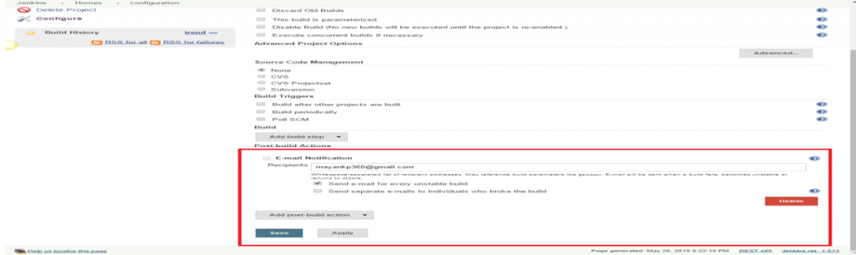](http://www.360logica.com/blog/wp-content/uploads/2016/02/image013.png)

13. Click the ‘Add post-build action’ drop-down and select the ‘Editable Email Notification’ value.

[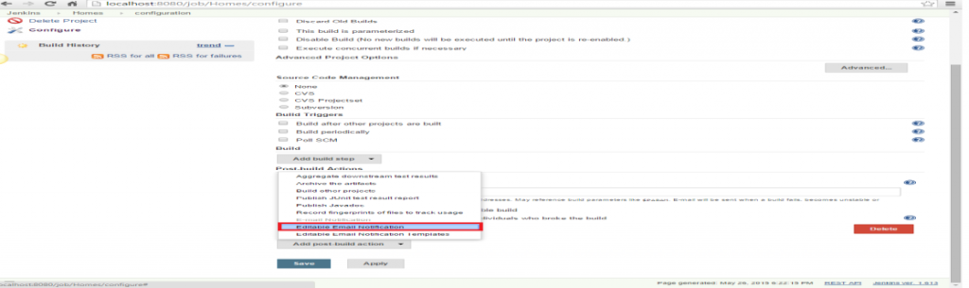](http://www.360logica.com/blog/wp-content/uploads/2016/02/image014.png)

14. Fill the ‘Editable Email Notification’ fields.

* Project Recipient List : email_id@gmail.com

[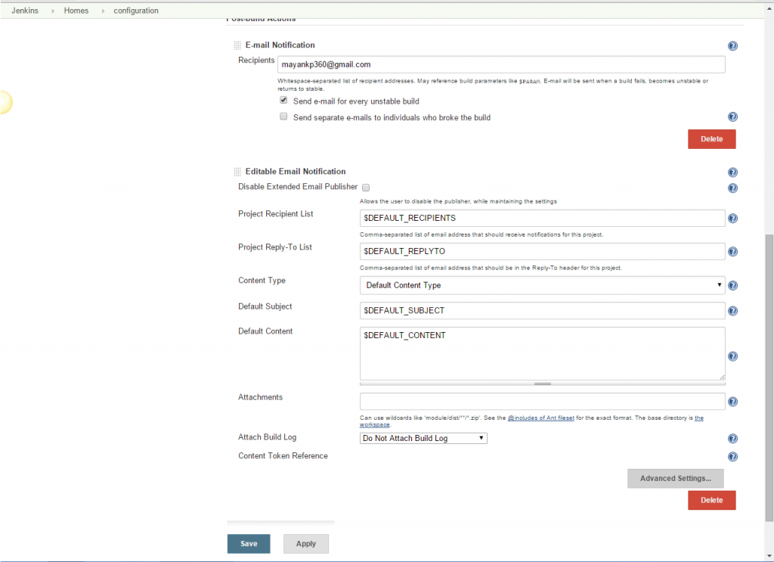](http://www.360logica.com/blog/wp-content/uploads/2016/02/image015.png)

15. Click the ‘Advance Settings…’ button in the ‘Editable Email Notification’ box.

16. Click the ‘Add Trigger’ drop-down and select the ‘Always’ option.

[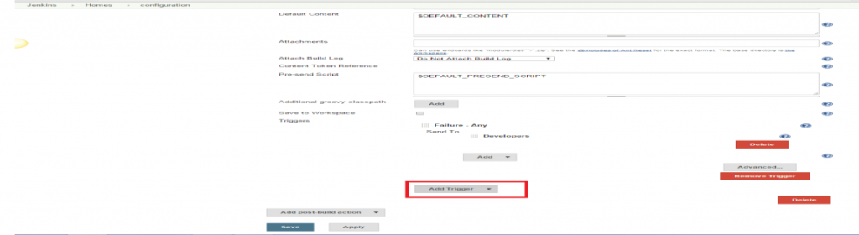](http://www.360logica.com/blog/wp-content/uploads/2016/02/image016.png)

[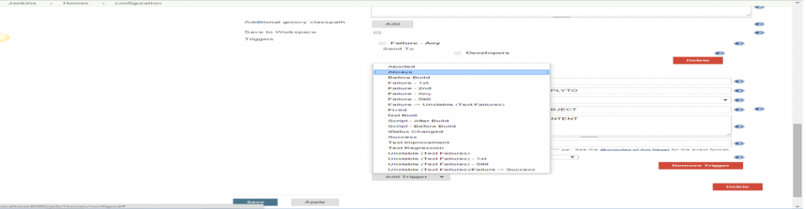](http://www.360logica.com/blog/wp-content/uploads/2016/02/image017.png)

17. Click the ‘Save’ button.

18. Go to the home page and click on the job, like Homes.

19. Click the ‘Build now’ link and check the email id after the job execution.

Second meyhod:

## **How to send Email at every build with Jenkins**

 Posted on Saturday Feb 22, 2014 at 09:34PM in Jenkins

## **Environment**

* Email-ext plugin 2.37.2
* Jenkins 1.551
* Apache Maven 3.1.1
* git version 1.8.3.4 (Apple Git-47)
* Oracle JDK7u51
* OS X 10.9.1

## **Install Email-ext plugin**

* Install Email-ext plugin at plug-in install page of Jenkins

## **Configure System**

### **“Jenkins Location” section**

1. Enter valid email address to “System Admin e-mail address”

### **“Extended E-mail Notification” section**

1. Enter your email address to “Default Recipients”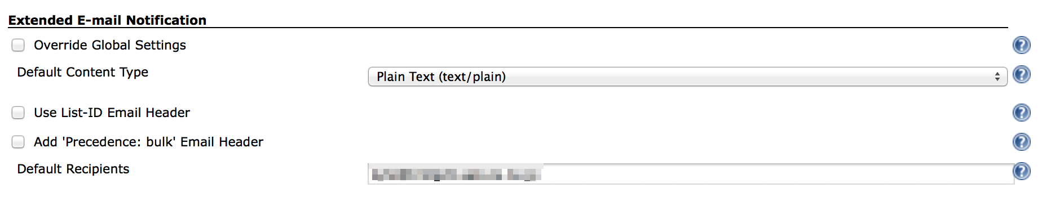

### **“E-mail Notification” section**

1. Enter your SMTP server name to “SMTP server”
2. Click “Advanced”
3. Click “Use SMTP Authentication”
4. Enter required informations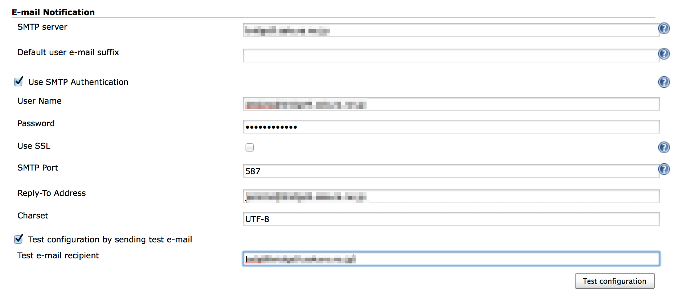
5. Check “Test configuration by sending test e-mail”
6. Click “Test configuration” to send test email
7. Click “Save” in the bottom of the page

## **Configure a project to send email at every build**

1. Click “Add post-build action”
2. Click “Editable Email Notification”
3. Click “Advanced Settings…”
4. Click “Add Trigger”
5. Click “Always”
6. Save

## **Test-run**

1. Click “Build Now”
2. Check Console output and received email

[INFO] ------------------------------------------------------------------------

[INFO] BUILD SUCCESS

[INFO] ------------------------------------------------------------------------

[INFO] Total time: 3.497s

[INFO] Finished at: Sat Feb 22 22:27:21 JST 2014

[INFO] Final Memory: 18M/245M

[INFO] ------------------------------------------------------------------------

[JENKINS] Archiving /Users/Shared/Jenkins/Home/jobs/BuildAndTestHead/workspace/hellojenkins/pom.xml to org.nailedtothex/hellojenkins/0.0.1-SNAPSHOT/hellojenkins-0.0.1-SNAPSHOT.pom

channel stopped

Archiving artifacts

Email was triggered for: Always

Sending email for trigger: Always

Sending email to: kyle@example.com

Finished: SUCCESS

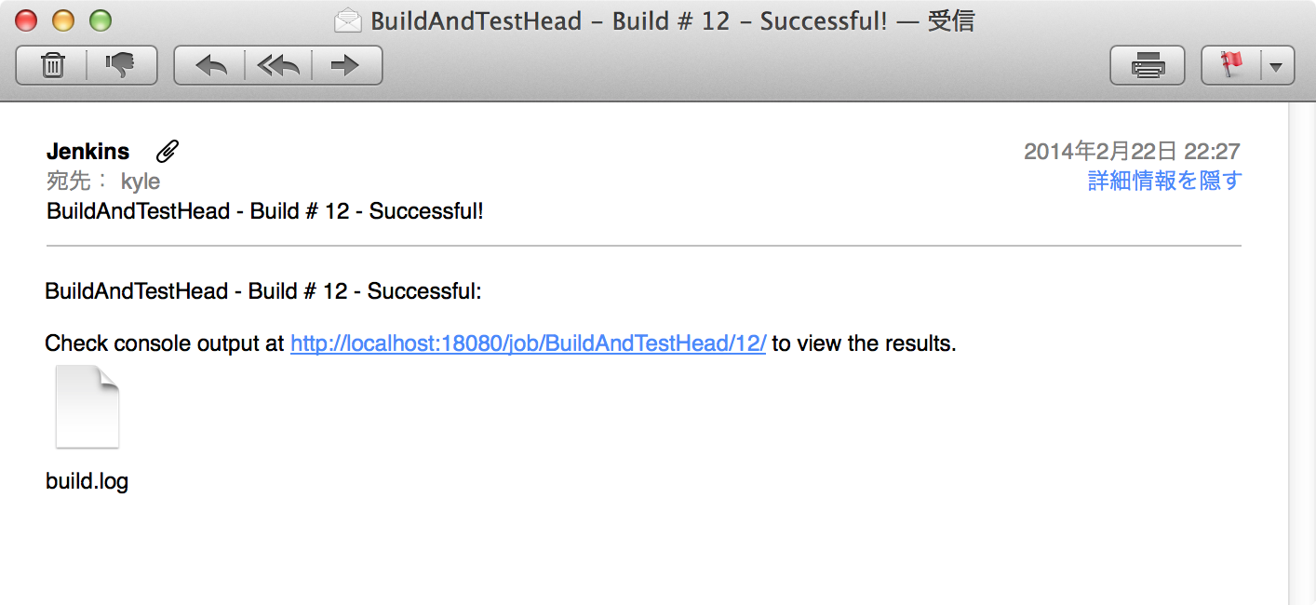

3rd method:

# Configuring the Mail Server

The last of the basic configuration options you need to set up is the email server configuration. Email is Jenkins’s more fundamental notification technique—when a build fails, it will send an email message to the developer who committed the changes, and optionally to other team members as well. So Jenkins needs to know about your email server (see [Figure 4-10](https://www.safaribooksonline.com/library/view/jenkins-the-definitive/9781449311155/ch04s08.html#fig-configure-email)).

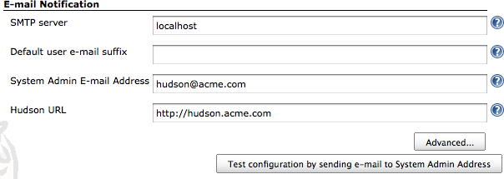

*Figure 4-10. Configuring an email server in Jenkins*

The System Admin email address is the address from which the notification messages are sent. You can also use this field to check the email setup—if you click on the Test configuration button, Jenkins will send a test email to this address.

In many organizations, you can derive a user’s email address from their login by adding the organization domain name. For example, at ACME, user John Smith will have a login of “jsmith" and an email address of “jsmith@acme.com”. If this extends to your version control system, Jenkins can save you a lot of configuration effort in this area. In the previous example, you could simply specify the default user email suffix of acme.com and Jenkins will figure out the rest.

You also need to provide a proper base URL for your Jenkins server (one that does not use localhost). Jenkins uses this URL in the email notifications so that users can go directly from the email to the build failure screen on Jenkins.

Jenkins also provides for more sophisticated email configuration, using more advanced features such as SMTP authentication and SSL. If this is your case, click on the Advanced button to configure these options.

For example, many organizations use Google Apps for their email services. You can configure Jenkins to work with the Gmail service as shown in [Figure 4-11](https://www.safaribooksonline.com/library/view/jenkins-the-definitive/9781449311155/ch04s08.html#fig-configure-gmail). All you need to do in this case is to use the Gmail SMTP server, and provide your Gmail username and password in the SMTP Authentication (you also need to use SSL and the non-standard port of 465).

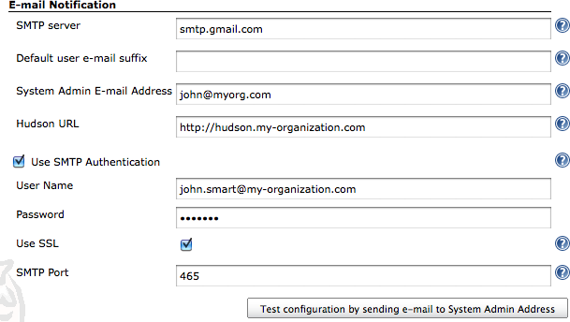

*Figure 4-11. Configuring an email server in Jenkins to use a Google Apps domain*